

2st Task: CFD Analysis

Of Different Values of Flow

**Authors**: Julen Arruti

Victor Navarrete

**Date:** 27/11/2018

**Subject**: Numerical Methods Of Heat And Mass Transfer

**Professor**: Ekaterina Kitanina

1. **- Problem Definition**

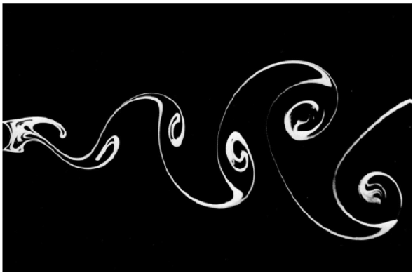

* **Physical Description**

The problem to be solved is that of **laminar flow around a cylinder**. The diameter of the cylinder is equal to 18 mm. The inlet air velocity and temperature are 0.42 m/s and 20 C correspondingly. The conditions correspond to a PIV experiment [1]. Since the flow coming to the cylinder was uniformed in a wind channel and the length of the cylinder is much longer than its diameter the flow can be treated as two-dimensional.

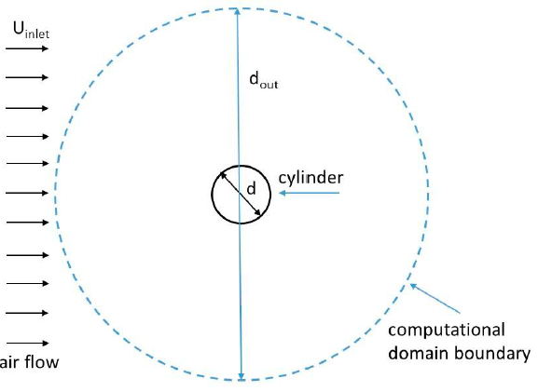

1. **- Results of the simulation:**

1stSimulation:

*Figure 1.1 Meshes*

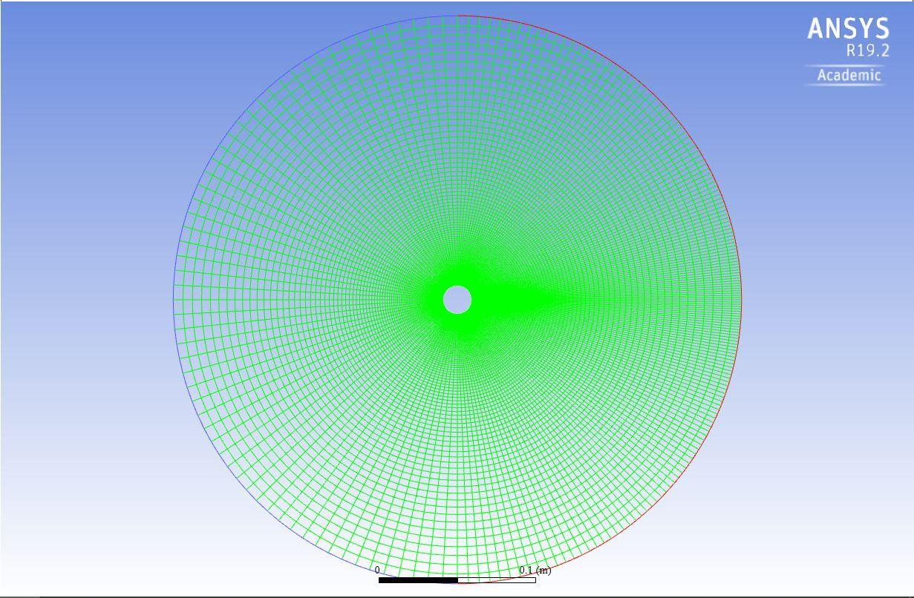

Source: Ansys simulations solutions (2018)

*Figure* 1.2 *Residual Results.*

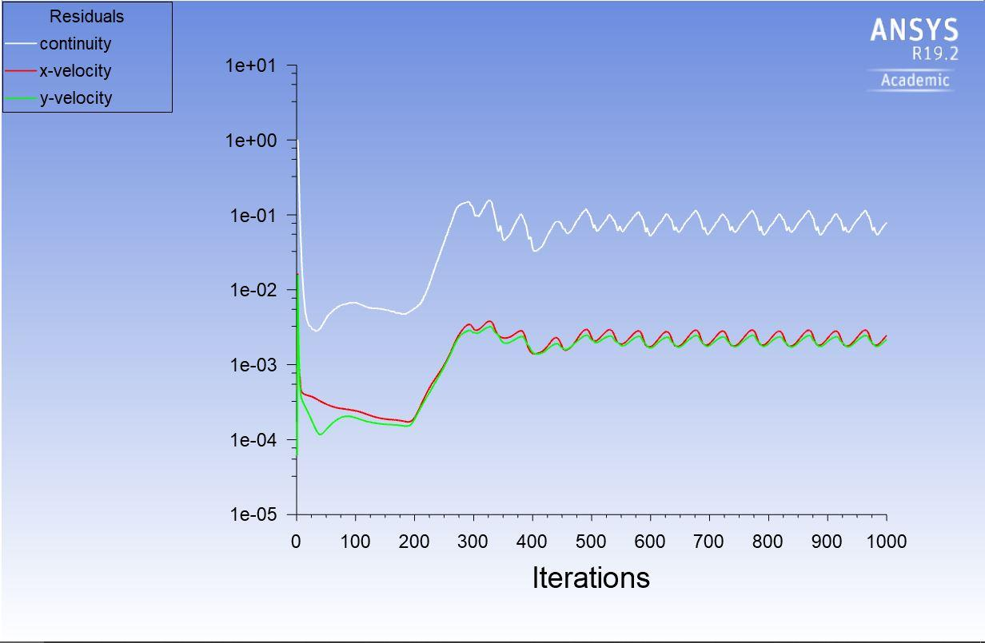

Source: Ansys simulations solutions (2018)

*Figure 1.3 Residuals*

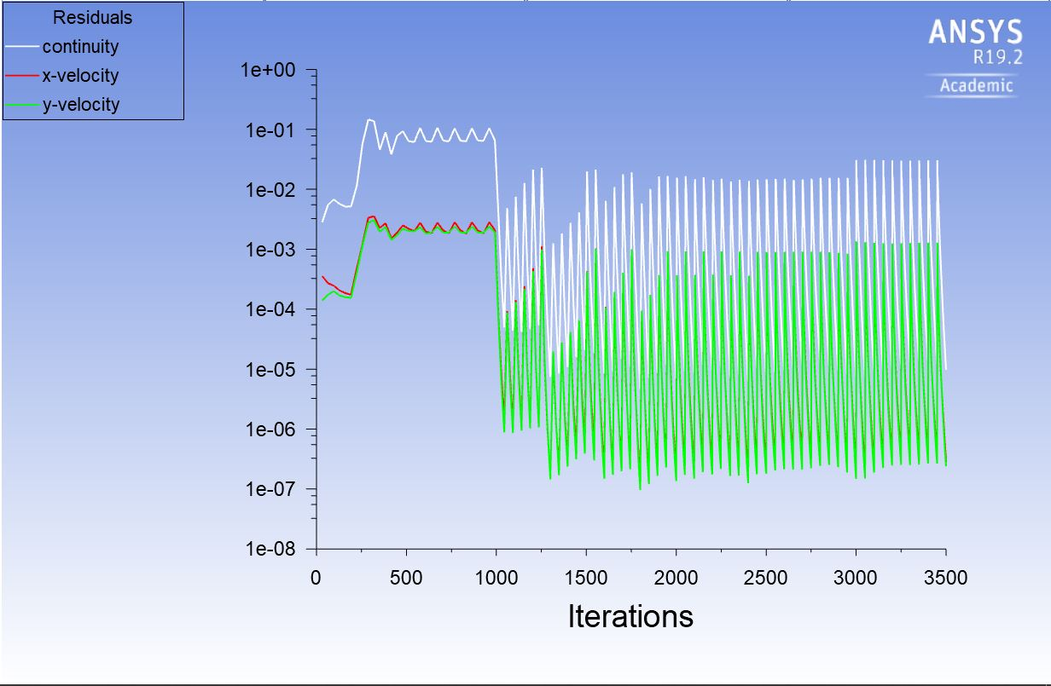

Source: Ansys simulations solutions (2018)

*Figure 1.4 Point Surface*

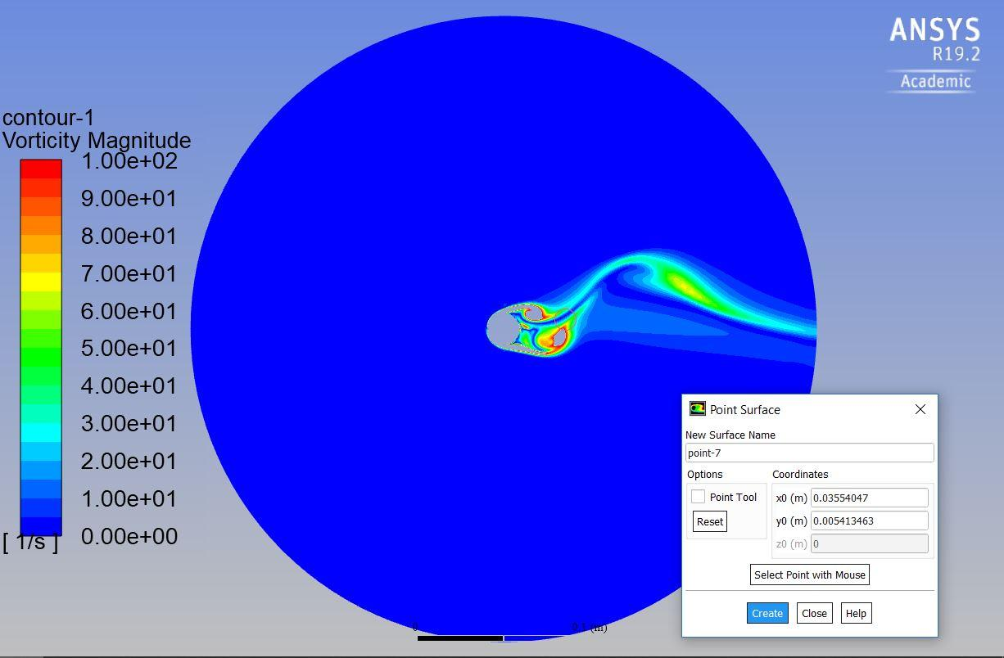

Source: Ansys simulations solutions (2018)

*Figure 1.5 Area-Weighted Average of Velocity –Magnitude at the point.*

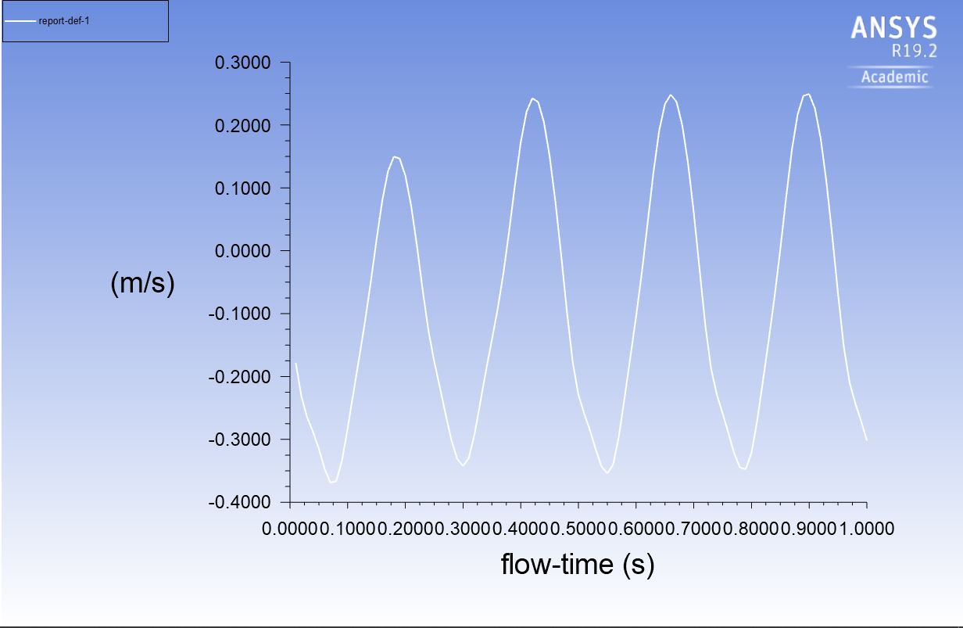

Source: Ansys simulations solutions (2018)

*Figure 1.6 Dynamic Pressures*

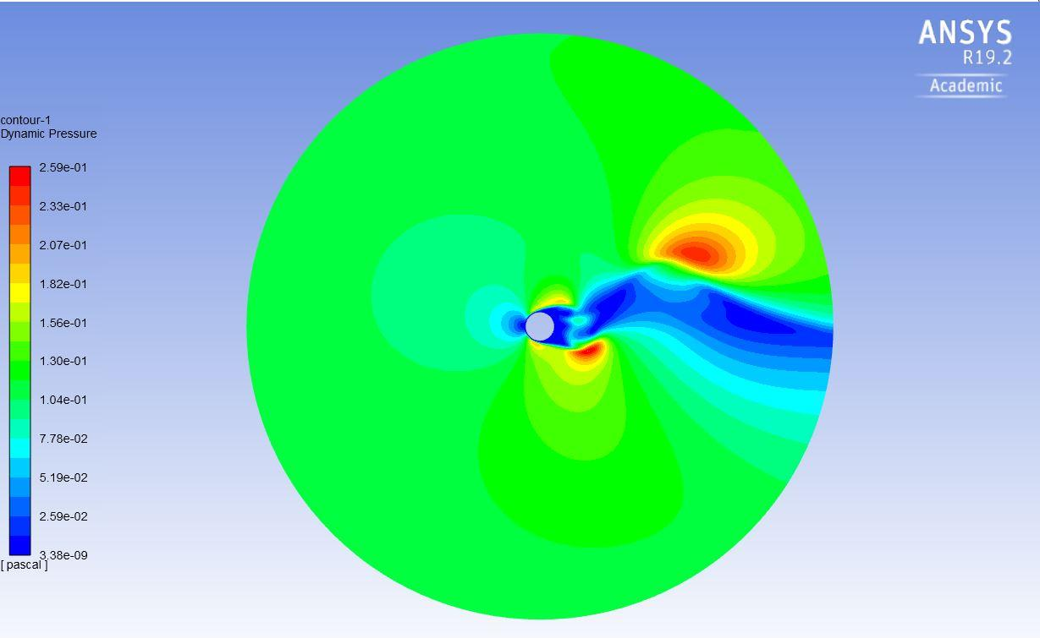

Source: Ansys simulations solutions (2018)

*Figure 1.7. Vorticity Magnitude*

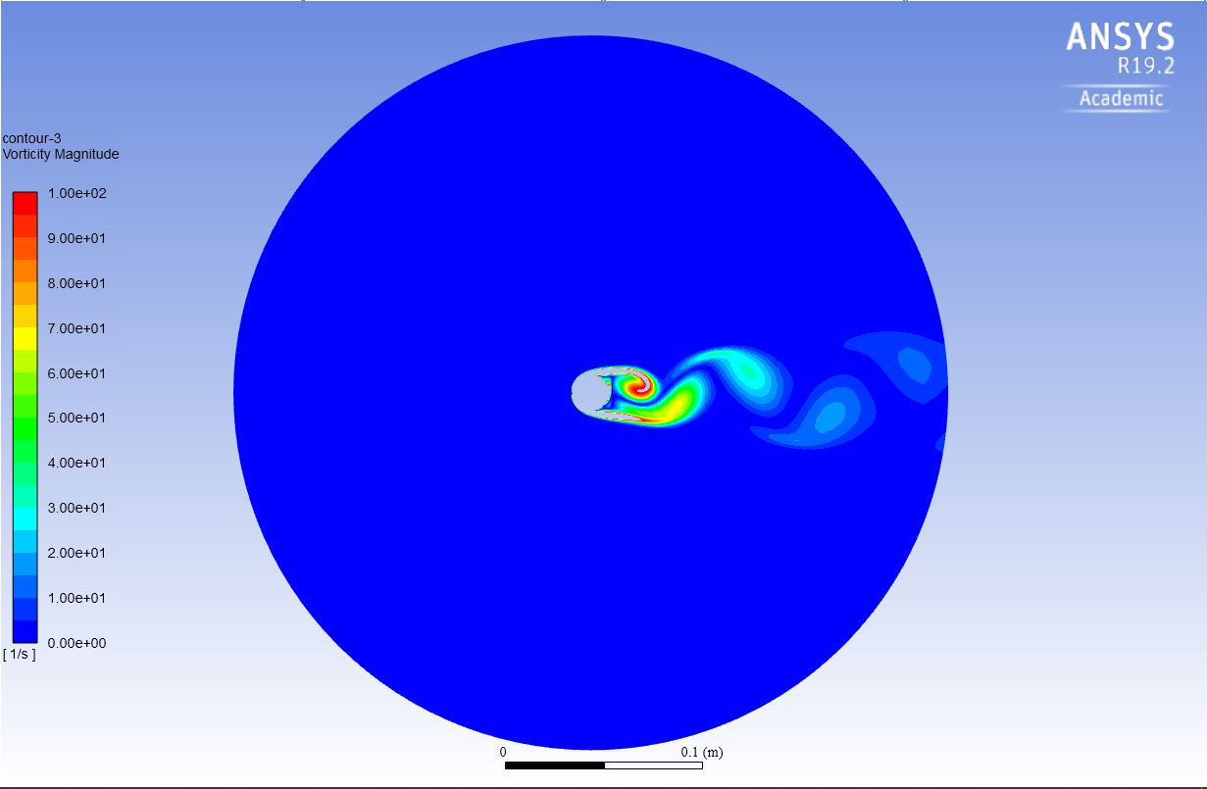

Source: Ansys simulations solutions (2018)

*Figure 1.8 Static Pressure*

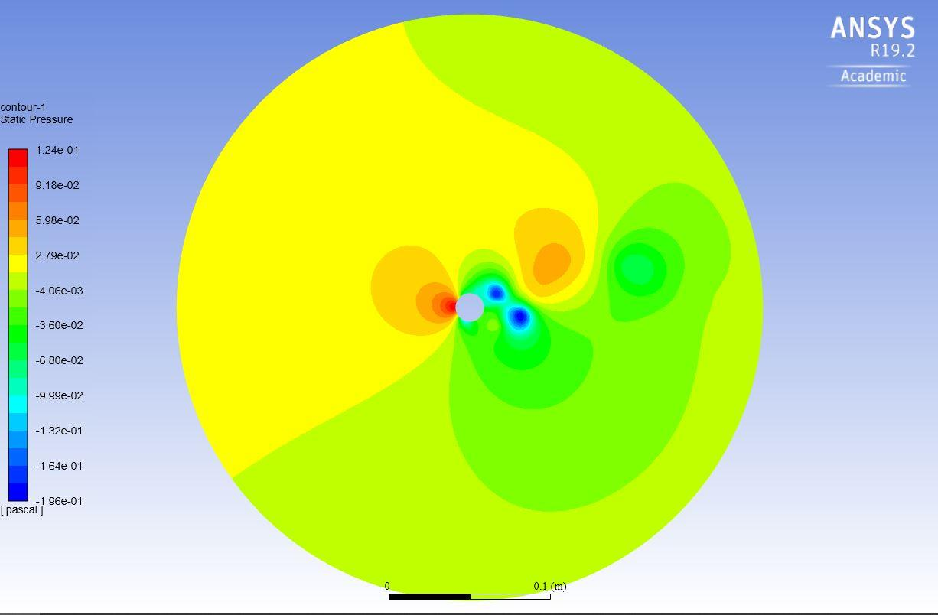

Source: Ansys simulations solutions (2018)

*Figure 1.9 Vorticity Magnitude.*

**

Source: Ansys simulations solutions (2018)

*Figure 1.10 Velocity Magnitude*

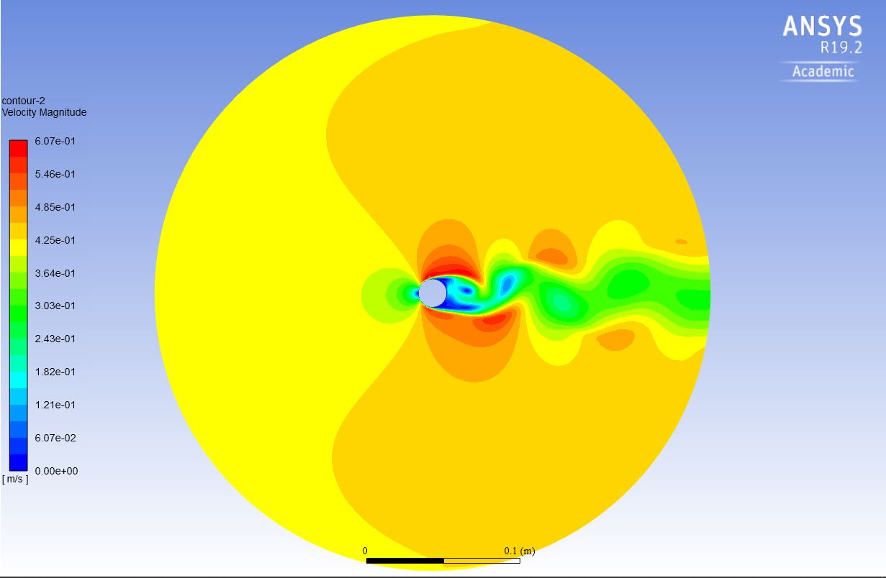

Source: Ansys simulations solutions (2018)

*Figure 1.11 Velocity Magnitudes*

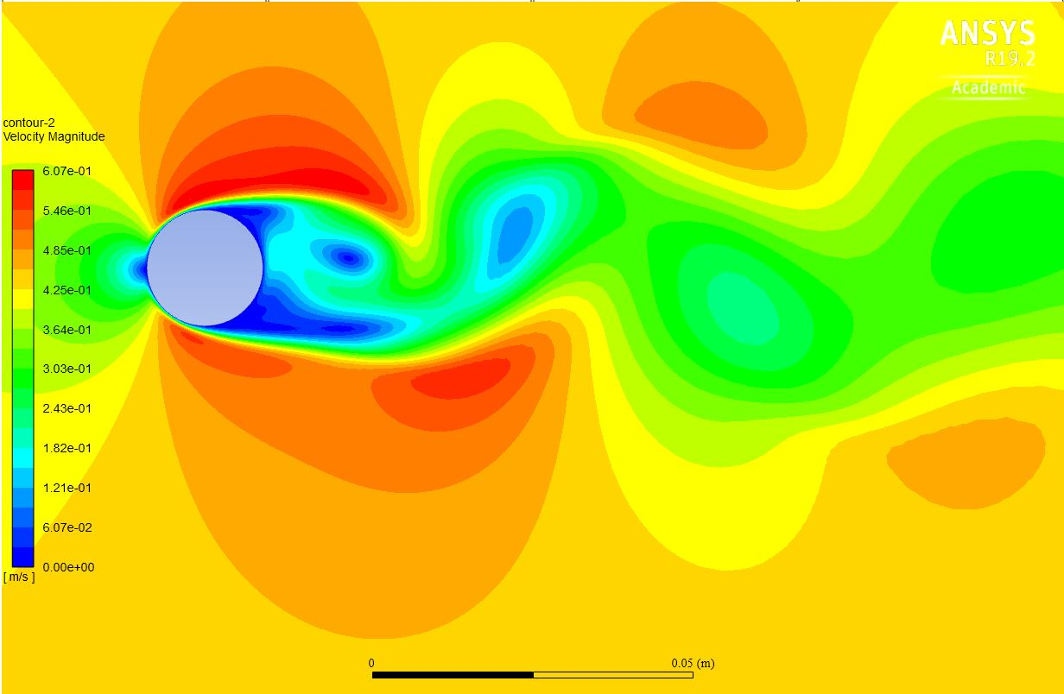

Source: Ansys simulations solutions (2018)

*Figure 1.12 Velocity Magnitudes*

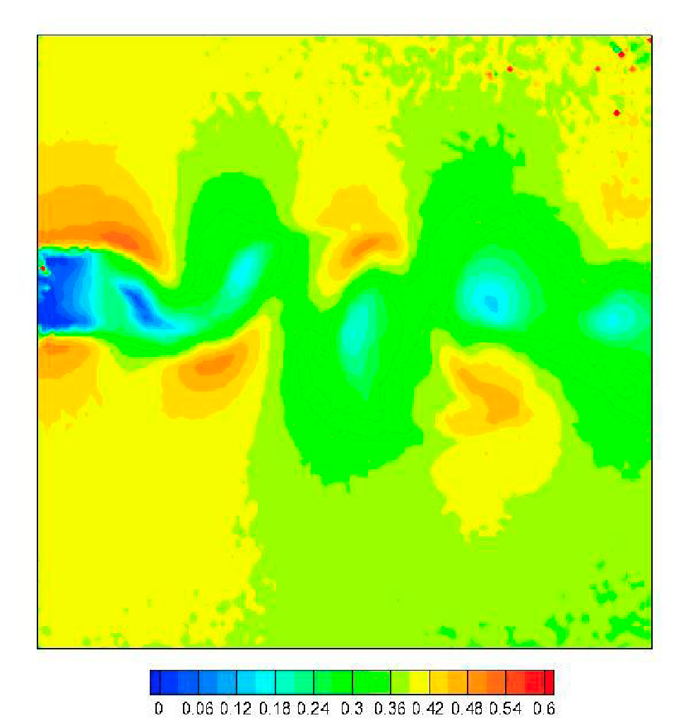

Source: Experimental PIV Data

*Figure 1.13 Vorticity Magnitude.*

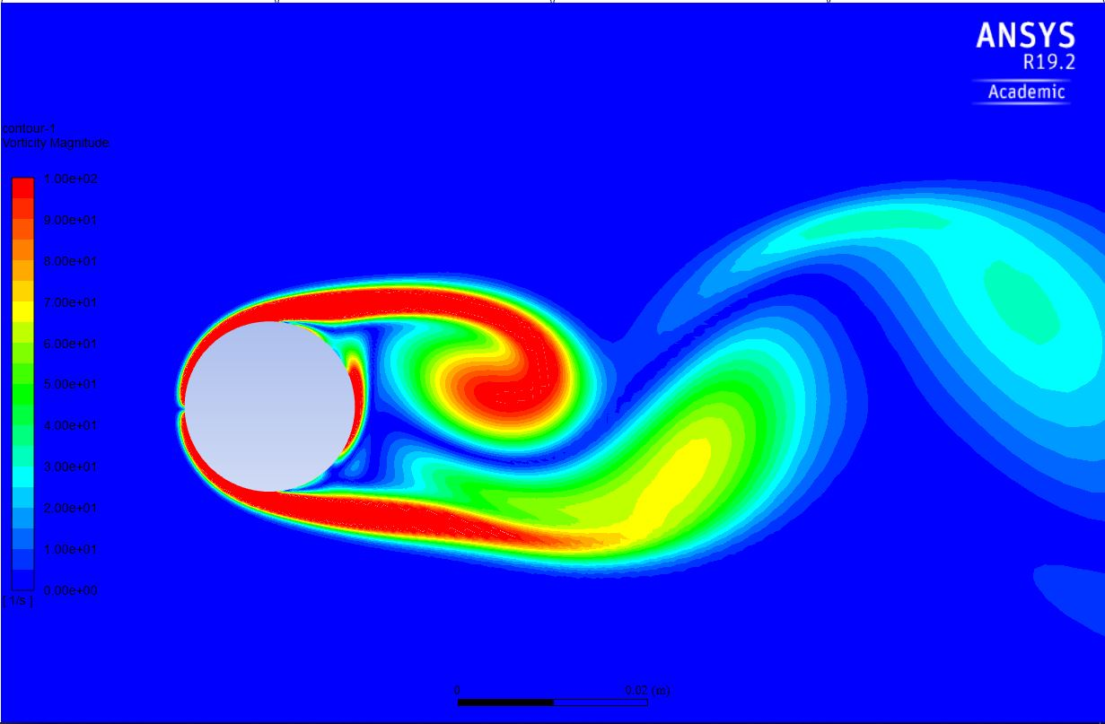

Source: Ansys simulations solutions (2018)

*Figure 1.14 Vorticity Magnitude.*

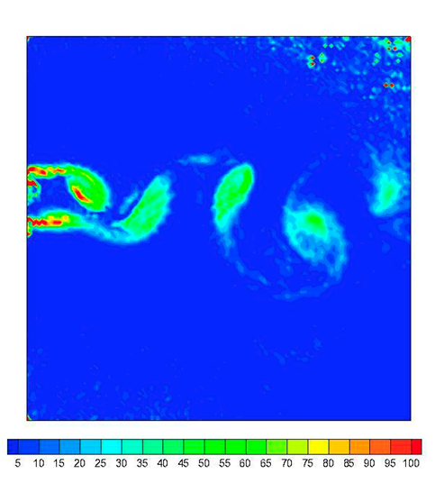

Source: Experimental PIV Data

As we can see both magnitudes velocity and pressure the general view look like similar, but at the experimental PIV data the level of details are higher. Then we can say that, in the simulation one is limited by the power of processing of the computer .

1. **- Analysis of the data:**

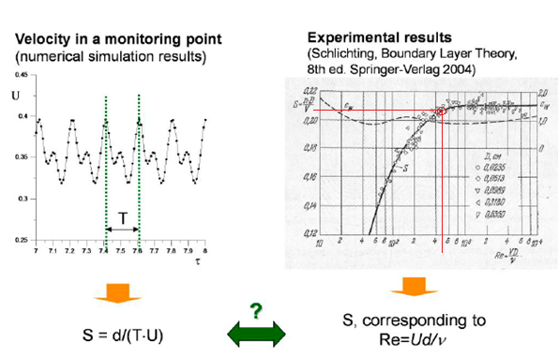

*Figure 1.15 Frequency in a point.*

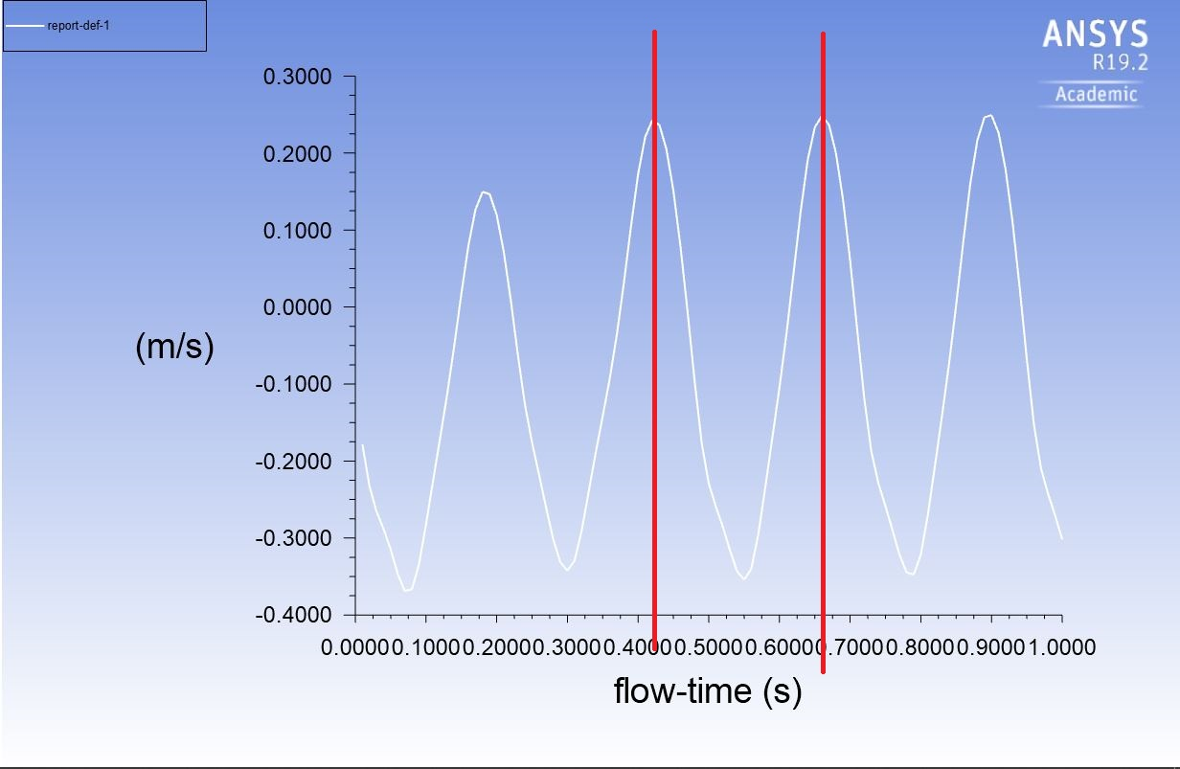

Source: Ansys simulations solutions (2018)

As we can see in the *Fig.* 1.15 the time lapse from one peak to the other is of 0,225s aprox.

If we compare the experimental result and the analytical we can observe that the results don’t match exactly. However, we can conclude that before starting the simulation we can have an idea of the results and how it is supposed to be the variation and frequency of the velocity in the point observed. This way we can test the suitability and the correction of the simulation we have designed and obtained.

* **Discretization of the control volume:**

We have increased the density of the mesh in the surroundings of the pipe right as it can be observed in *Figure 1.1.*

* **Analysis of the residual:**

If we watch the results obtained in the simulation of the residuals show us that the value of the residuals obtained in the chart of the experiment, *Fig. 1.2*, the values are not as small as we would like (1e-6) but this is reasonable because of the instability of the flow.

* **Analyses of the velocity vectors:**

In regard with the results obtained in the *Fig.1.11,* velocity vectors chart shows us clearly how the vortexes occur in the tail of the flow. If we pay attention to the flow around the pipe, we can see that near the pipe no vectors are shown and we could think that around it the velocity is so low that is not taken into account but it’s just the opposite; the velocity in the inlet and around the pipe the velocity is so high that can’t be registered in the same range velocities as the range of the vortices.